LAB 08 - Navigation Controller

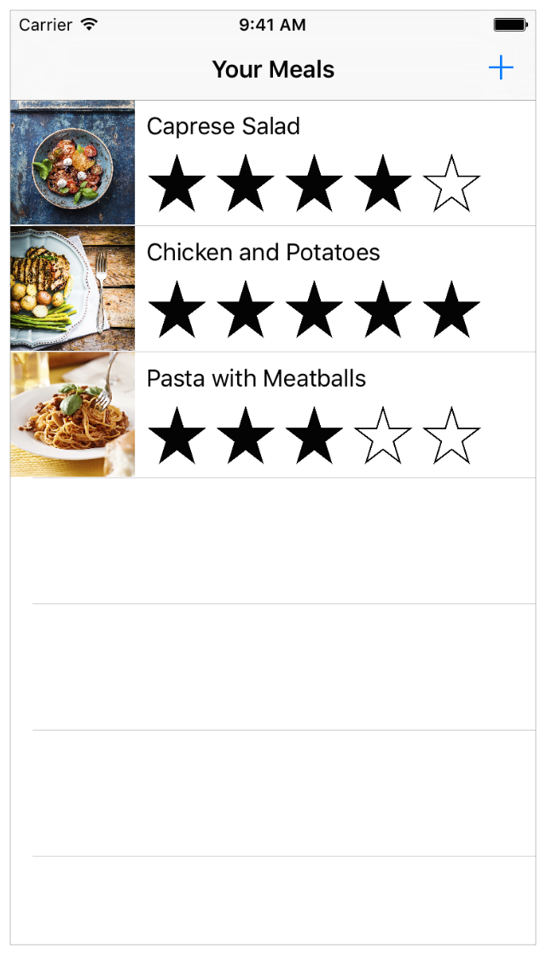

Objectives

* Create navigation Controller
* Create unwind scena
* Passing parameters between controllers

## Agregar Navigation Controller

Seleccionar Editor > Embed In > Navigation Controller.

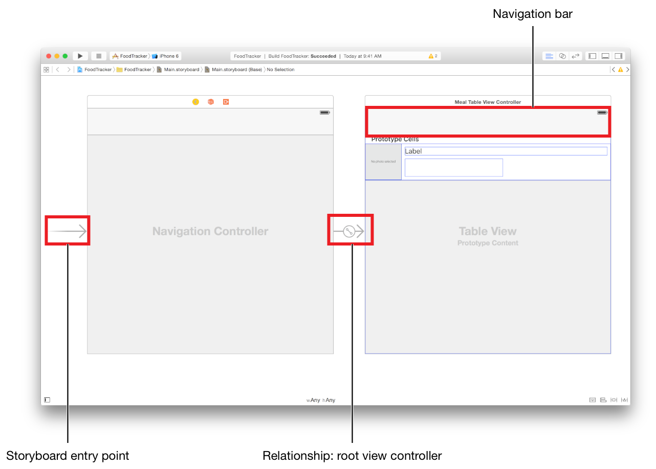

## Configure the Navigation Bar for the Scenes

Doble click en el navigation bar y cambiar el nombre

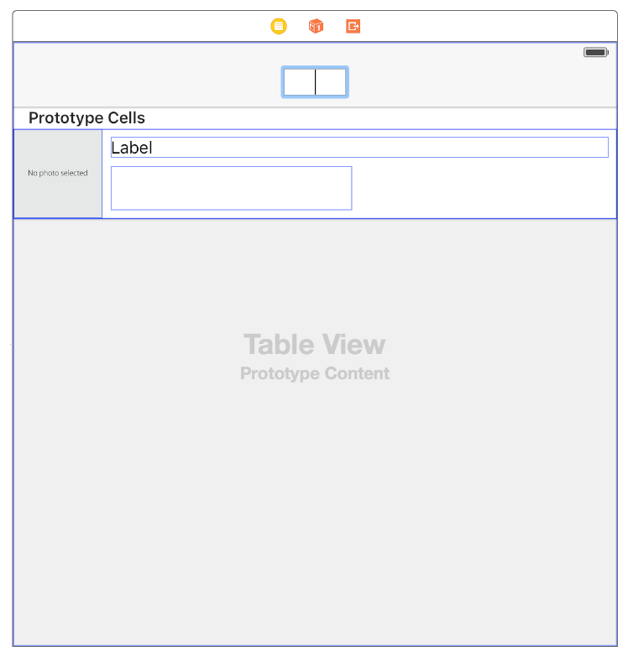

Agregar un Bar Button Item

* Buscar en el object library “bar button Item” y arrastrar al lado superior derecho

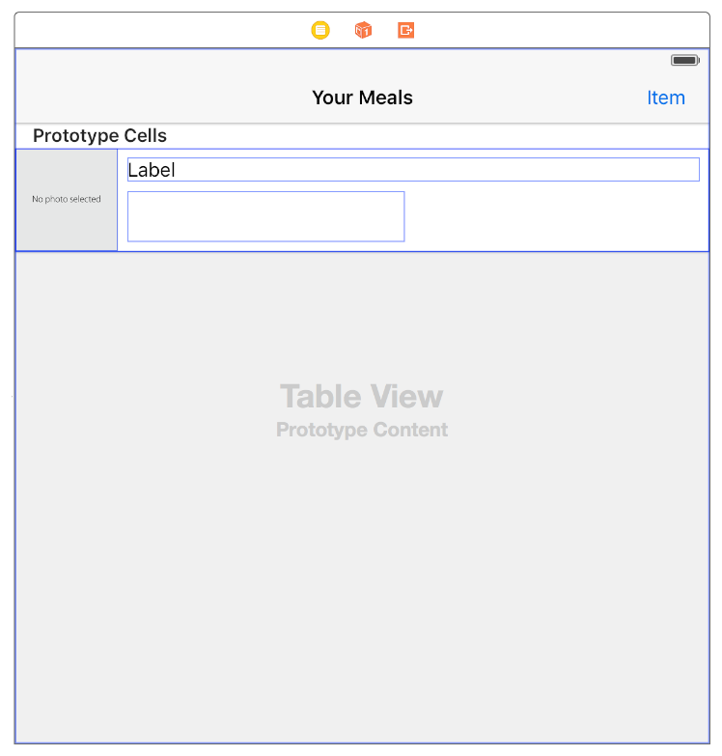

en el Attributes inspector, seleccionar el campo System Item option.

y cambiar a button (+).

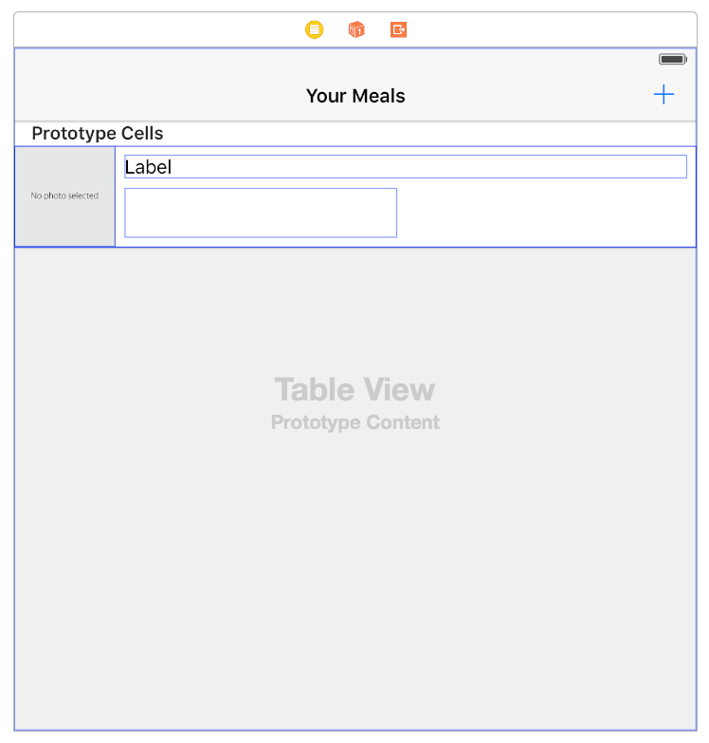

**Configurar el boton (+) a la siguiente scena**

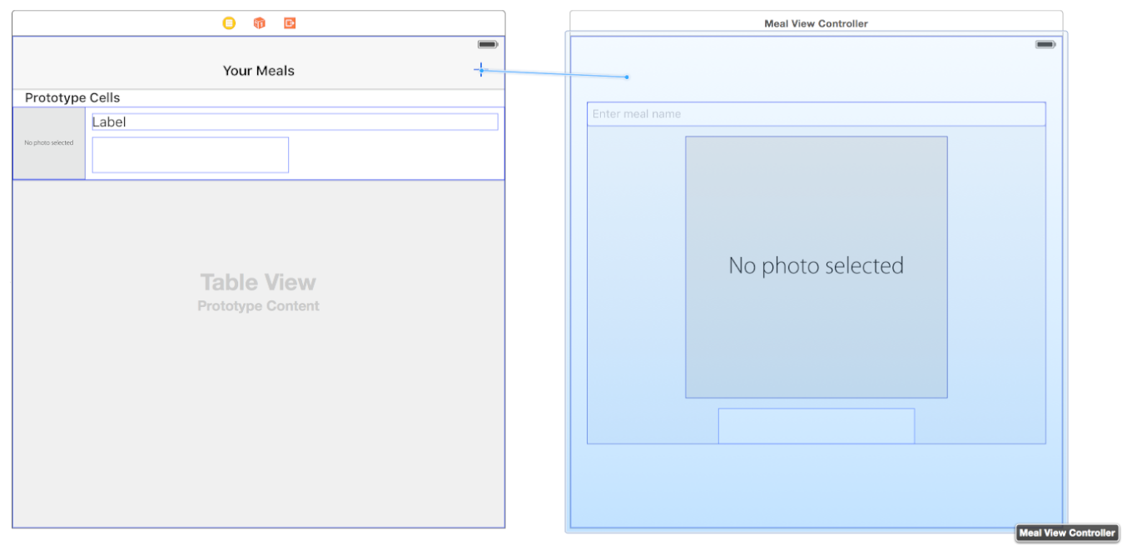

**en el popup seleccione el tipo de acción a Show**

**Embed again into Navigation Bar**

* **select Meal Scene y**

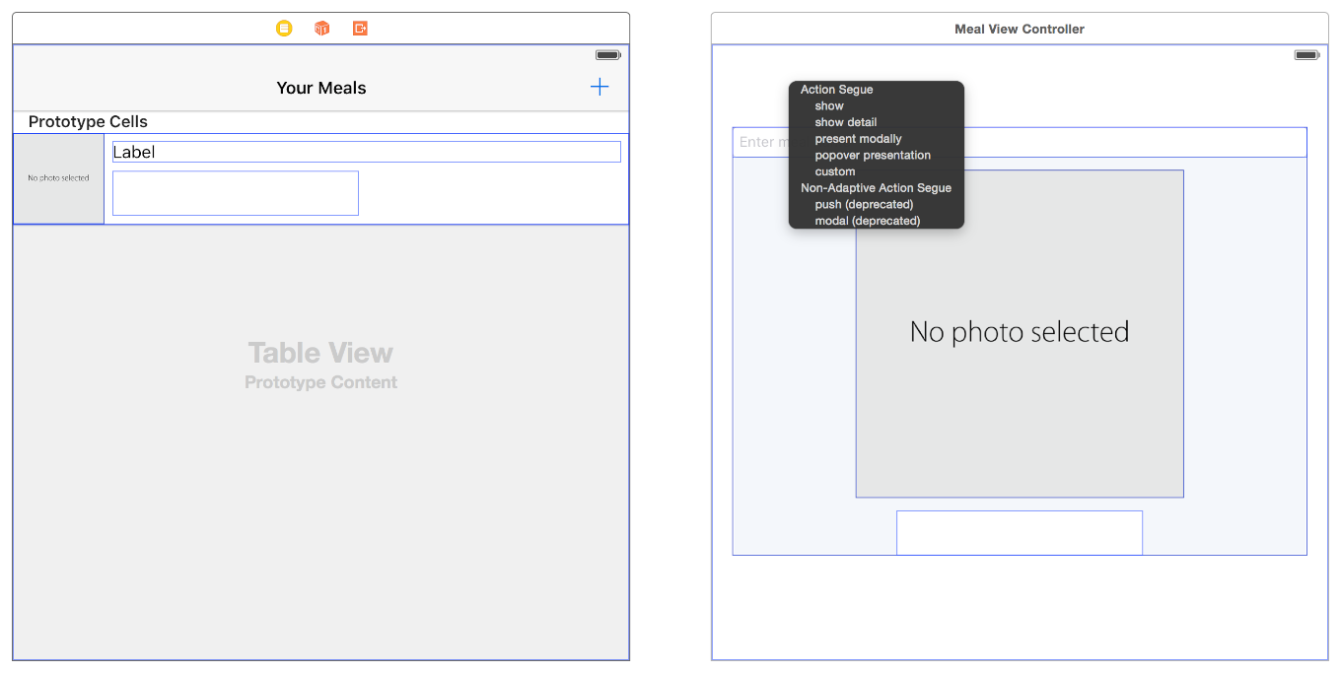

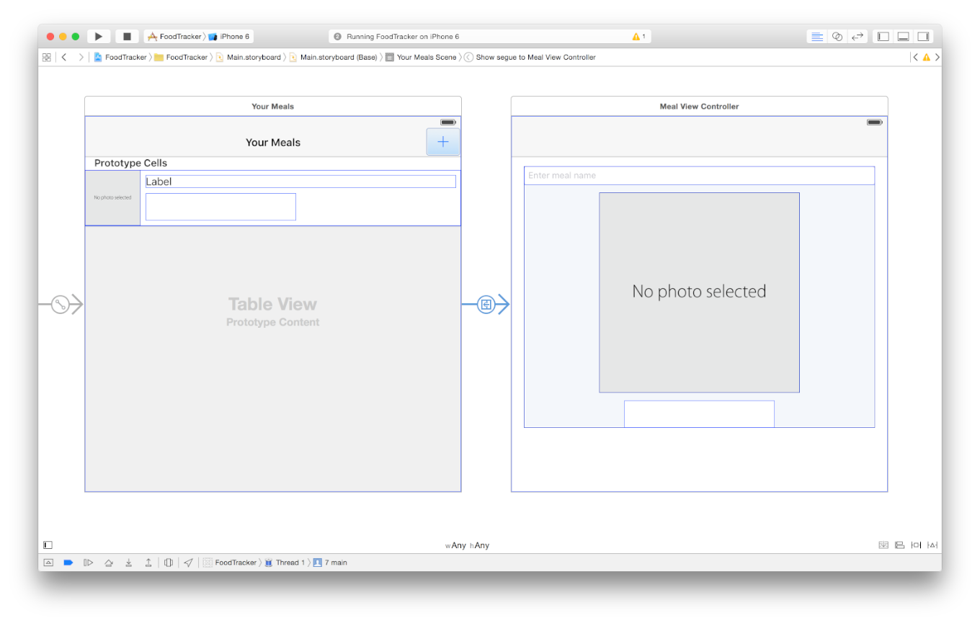

### Embed Navigation Controller

**Seleccionar el segue, attribute inspector y poner el Id “AddItem”**

**agregar Navigation al scena Meal :**  Embed In > Navigation Controller.

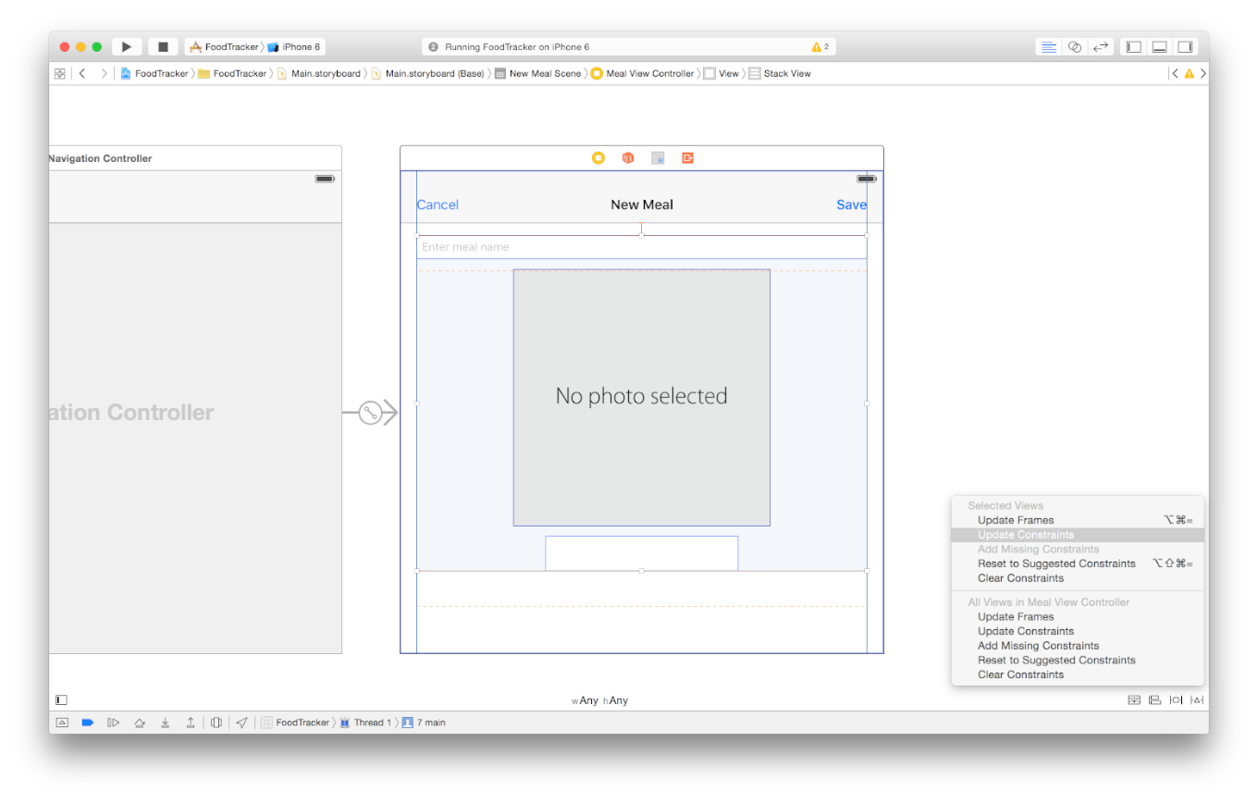

### Crear Unwind Segue in table view Controller

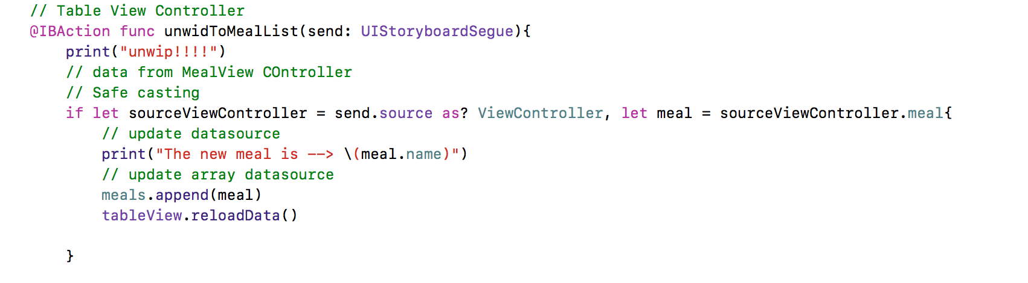

**Link exit Meal Scena**

**Seleccionar el item button y linkear con el button (+) y exit de la scena**

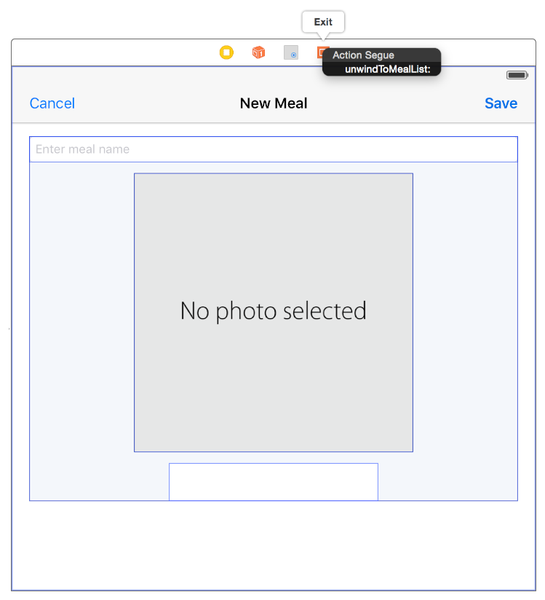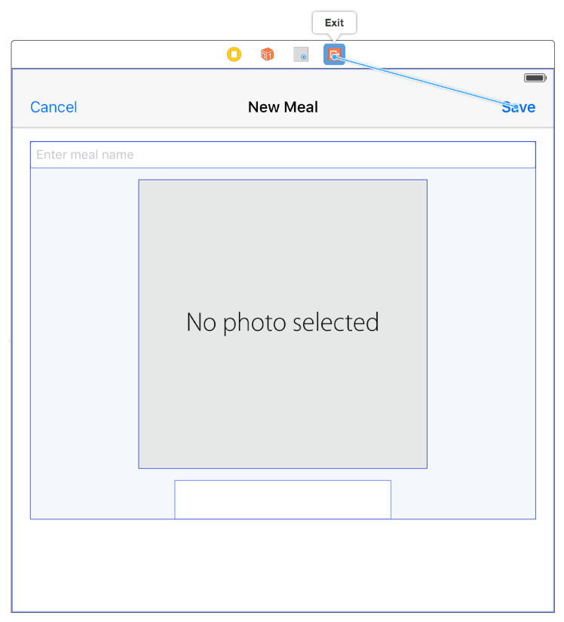

**Choose unwindToMealList: from the shortcut menu.**

**Implementar el modelo en MealViewController**

**incluir el boton Save al codigo:**

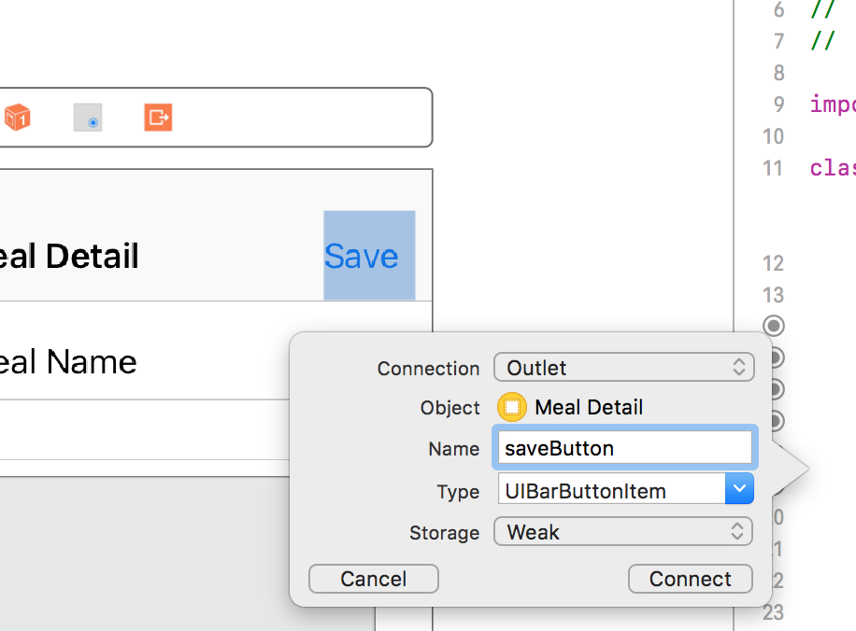

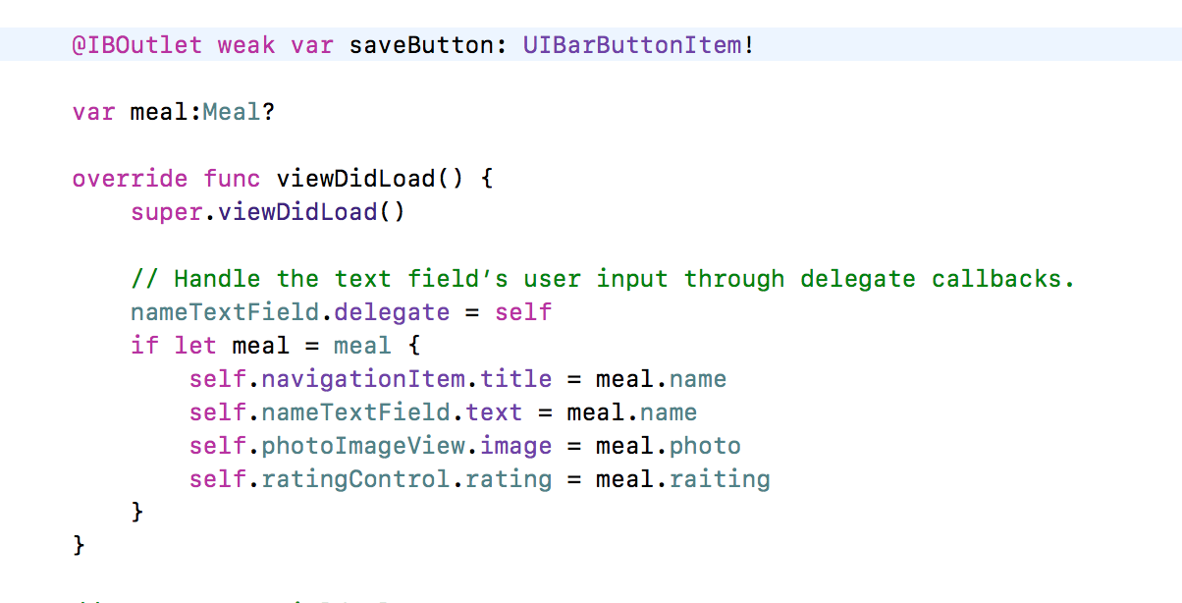

**Incluir el Model Meal al controlador ViewController o MealViewController**

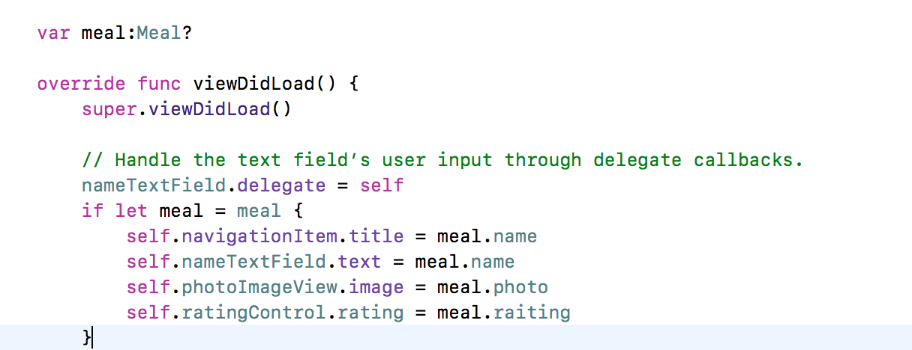

**Enviar los datos del Meal COntroller al Table view controller, override the method prepare in MealViewController or ViewController**

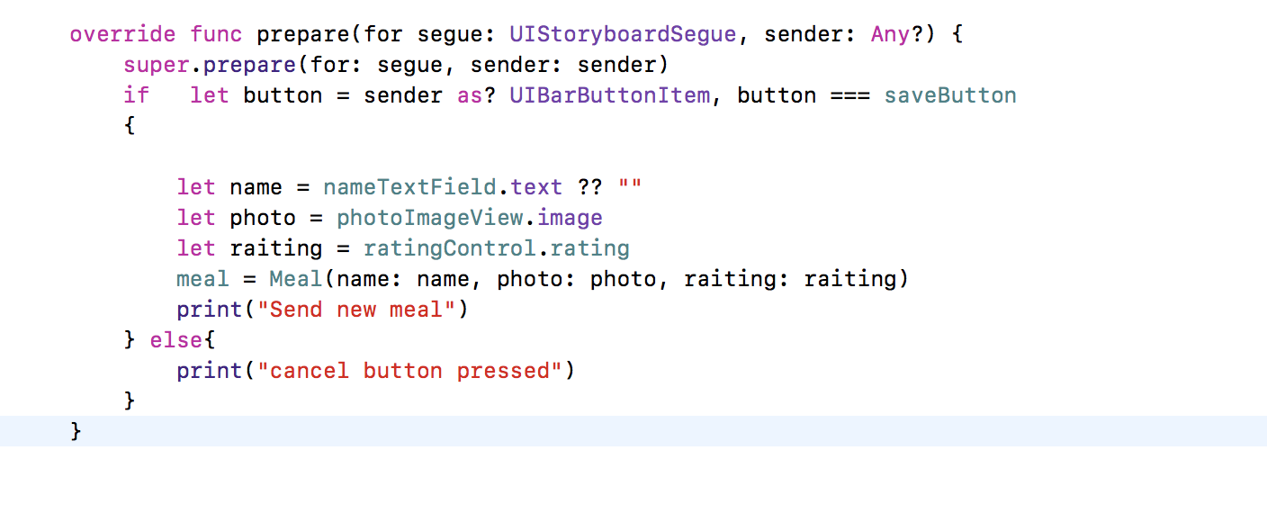

**Update && Delete**

* **add Edit button**

**in TableViewController:**

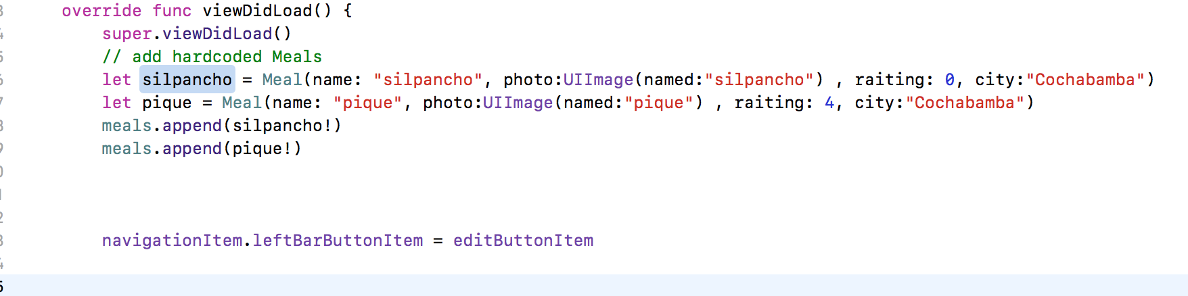

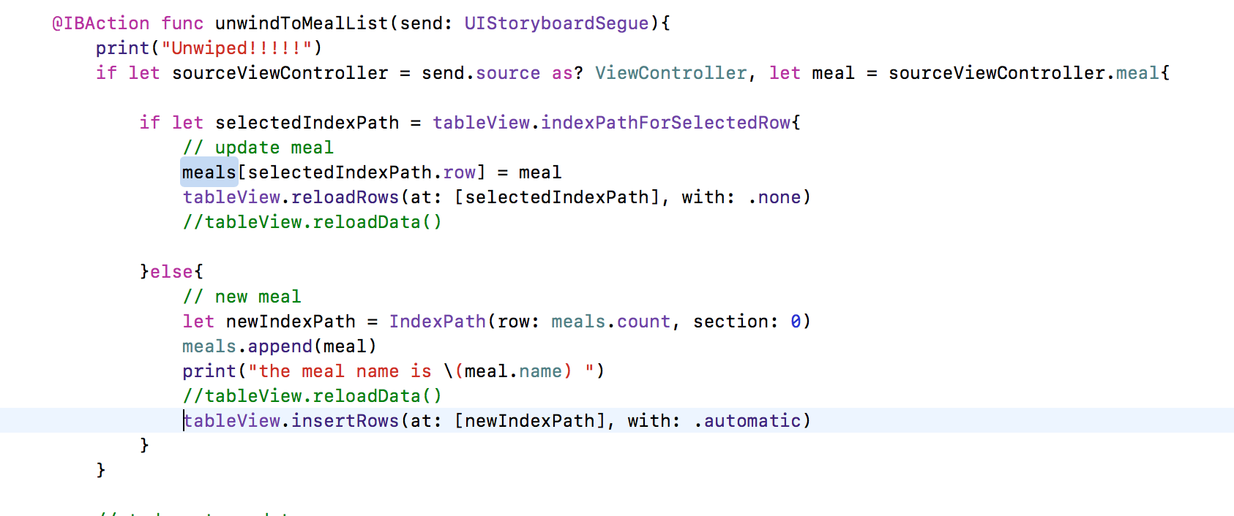

**Delete**

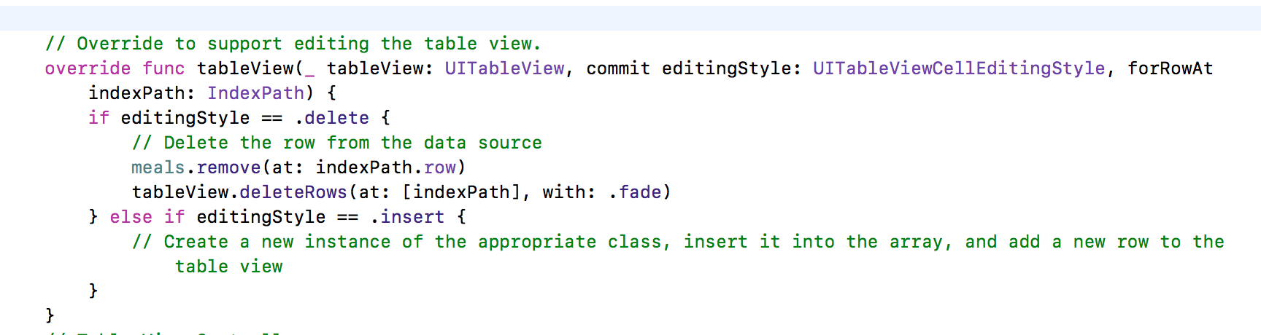

**Edit**

**In Table View :**

**override func prepare(for segue: UIStoryboardSegue, sender: Any?) {**

**super.prepare(for: segue, sender: sender)**

**switch(segue.identifier ?? "") {**

**case "AddItem":**

**print("add Item")**

**//os_log("Adding a new meal.", log: OSLog.default, type: .debug)**

**case "ShowDetail":**

**print("Show Detal")**

**guard let mealDetailViewController = segue.destination as? ViewController else {**

**fatalError("Unexpected destination: \(segue.destination)")**

**}**

**guard let selectedMealCell = sender as? FoodTableViewCell else {**

**fatalError("Unexpected sender: \(sender)")**

**}**

**guard let indexPath = tableView.indexPath(for: selectedMealCell) else {**

**fatalError("The selected cell is not being displayed by the table")**

**}**

**let selectedMeal = meals[indexPath.row]**

**mealDetailViewController.meal = selectedMeal**

**default:**

**print("Default")**

**//fatalError("Unexpected Segue Identifier; \(segue.identifier)")**

**}**

**}**

**// Cancel Button in ViewCOntroller**

**@IBAction func cancelButtonClick(_ sender: Any) {**

**print("click!!dismiss")**

**dismiss(animated: true, completion: nil)**

**let isPresentingInAddMealMode = presentingViewController is UINavigationController**

**if isPresentingInAddMealMode {**

**dismiss(animated: true, completion: nil)**

**}**

**else if let owningNavigationController = navigationController{**

**owningNavigationController.popViewController(animated: true)**

**}**

**else {**

**fatalError("The MealViewController is not inside a navigation controller.")**

**}**

**}**